Application Note: Doppler radar

|  |  |
| --- | --- |
| Author | Sam Mentens |

Content

1 Introduction 1

2 Material and methods 2

3 Results 2

3.1 Subtitle 1 2

3.1.1 Subtitle 2

3.1.2 Subtitle 2

3.2 Subtitle 2 2

3.2.1 Subtitle 2

3.2.2 Subtitle 2

4 Discussion 2

5 Reference list 2

# Introduction

This project is a speedometer based on a doppler-radar. It measures the speed of a moving object with an accuracy of 0.24 m/s. It is an affordable, easy to make project and most of the components are within reach.

There are three types of speedometers a mechanical, an electromechanical and an electronic speedometers. This project is an electronic type.

These type of speedometer are frequently used in speed cameras on the side of the road.

In this Application Note these topics will be discussed: the materials and methods used in the project, the results and the obstacles encountered during the project.

# list of abbreviations used

IC: integrated circuit

SMD: suface-mounted device

PCB: printed circuit board

# Material and methods

|  |  |  |  |  |  |
| --- | --- | --- | --- | --- | --- |
| Type | Component | Component nr. | Price a piece (€) | Supplier | Delivery Date |
| Resistor (Ω) | 1K | CRCW1206100KFKEA | 0.04 | Mouser | 07/04/2021 |
|  | 2K | ERJ-3EKF2001V | 0.085 | Mouser | 07/04/2021 |
|  | 10K | CR0805-FX-1002ELF | 0.022 | Mouser | 07/04/2021 |
|  | 20K | ERA-8AEB203V | 0.56 | Mouser | 07/04/2021 |
|  | 31,6K | RT0402BRD0731K6L | 0.339 | Mouser | 07/04/2021 |
|  | 64,9K | CRCW060364K9FKEA | 0.08 | Mouser | 07/04/2021 |
|  | 100K | CRCW1206100KFKEA | 0.085 | Mouser | 07/04/2021 |
|  | 180K | ERJ-14YJ184U | 0.144 | Mouser | 07/04/2021 |
|  | 210K | RP73D2B210KBTG TE | 0.923 | Mouser | 07/04/2021 |
| Battery | 9V | 1294 | 2.98 | Mouser | 07/04/2021 |
| Display | 7-segment | SA10-21SRWA | 3.63 | Mouser | 07/04/2021 |
| Oscillator | 8000MHz | ASFL1-8.000MHZ-EK-T | 1.37 | Mouser | 07/04/2021 |
| Transceiver |  | K-LC5-RFB-00D | 22.965 | Digi-Key | 12/04/2021 |
| Switch |  | 6612 | 3.58 | Mouser | 07/04/2021 |
| Header | 2-pin male | 0022232021 | 0.134 | Digi-Key | 12/04/2021 |
|  | 3-pin male | 90120-0763 | 0.91 | Mouser | 07/04/2021 |
|  | 5-pin female | PPPC051LFBN-RC | 0.4 | Digi-Key | 12/04/2021 |
|  | 6-pin male | 640456-6 TE | 0.254 | Mouser | 07/04/2021 |
| Semi-conductor | D1 | MBRS540T3G | 0.4452 | Mouser | 07/04/2021 |
|  | D2 | 1N4148WS | 0.136 | Mouser | 07/04/2021 |
|  | D3 | MBR120LSFT1G | 0.339 | Mouser | 07/04/2021 |
| Transistor | NPN | BC847C | 0.109 | Nexperia | 4/03/2021 |
| Integrated circuit (IC) | IC1 | DSPIC33EP128GP502-I/SS | 2.53 | Mouser | 07/04/2021 |
|  | IC2 | AD7680ARJZ-REEL7 | 9.91 | Mouser | 07/04/2021 |
|  | IC3 | ADP3336ARMZ | 2.49 | Digi-Key | 12/04/2021 |
|  | IC5 | ADP150AUJZ-3.0-R7 | 0.889 | Mouser | 07/04/2021 |
|  | IC6-9 | SI3865DDV-T1-GE3 | 0.44 | Mouser | 07/04/2021 |
|  | IC10 | AD8656ARZ | 3.07 | Mouser | 07/04/2021 |
|  | IC11 | MCP16301HT-E/CH | 0.92 | Digi-Key | 12/04/2021 |
| Capacitator | 1nF | GRM1555C1H102JA01D | 0.085 | Mouser | 07/04/2021 |
|  | 100nF | CL31B104KBCNNNL | 0.077 | Mouser | 07/04/2021 |
|  | 1uF / 16V | CC0603KRX7R7BB105 | 0.152 | Mouser | 07/04/2021 |
|  | 2.2uF / 16V | [CL10A225KO8NNNC](https://www.mouser.be/ProductDetail/Samsung-Electro-Mechanics/CL10A225KO8NNNC?qs=sGAEpiMZZMsh%252B1woXyUXj9g54gsRQVPnDBKCF%2FKX%2FWw%3D) | 0.032 | Mouser | 07/04/2021 |
|  | 10uF / 16V | EMK316AB7106KLHT | 0.271 | Mouser | 07/04/2021 |

Table 1 Bill of materials

Ordered at: 30/03/2021

There are a lot of Surface-mounted devices ( SMDs ) instead of through hole components because of the size. SMDs take less space than through hole components.

Then the K-LC5 is used as radar transceiver because it is a low budget and low voltage hyphen transceiver. Compared to the other transceivers its small and has a great detection range for the size of it.

For the power supply there is a 9V battery that supplies power to the displays. A 12V Battery is also an option for this project. First there is a part that generates 5V for the radar transceiver. Secondly there is a 3.3V supply supplied by IC4 or IC11, this is for IC1 and the oscillator. Third there is IC5. IC5 generates a low-noise 3V. This supplies the opamps and the ADC.

The DSPIC33EP128GP502-I/SS needs to be programmed. This is done with Microchip’s X IDE for programming and debugging. It is an open source program for microchips. Then XC16 is used as compiler for the program. It supports the dsPIC family. Then also a library is needed to make the program word.

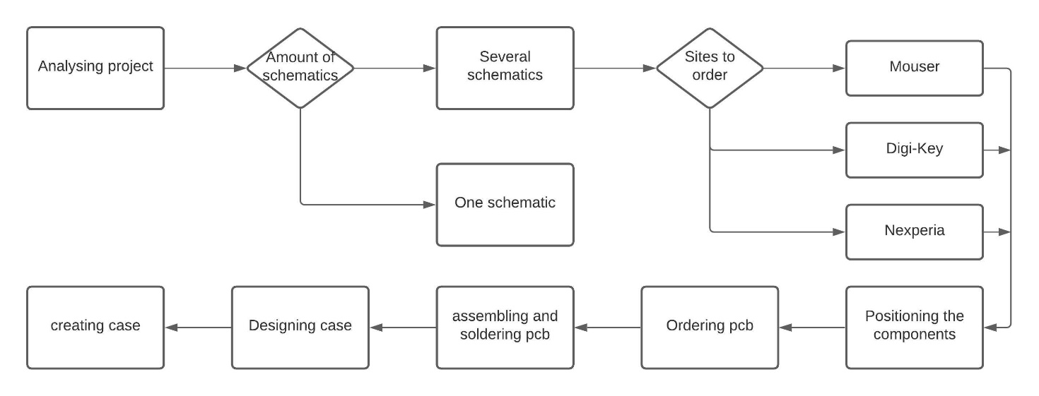

Figure 1 Flowdiagram

The project started with analysing this project that includes reading the description about the project and looking if there are any difficult to get components. Then came drawing the schematics and it could be split up in spacings different particles or made in one schematic. Because it is a large schematic, it is divided up in four schematics. It is more clear this way.

Then the components are ordered from different websites, because of the delivery date and availability. Mouser is used the most because it was one of the lowest in the price. Digi-Key is used mostly for components with a long delivery time or that were not available on mouser. Lastly Nexperia is used for a specific transistor that was not found on most websites.

Positioning the components is placing the components on a 3D design based on the schematics. The SMD components are mostly soldered on one side (mainly on the topside). Case mounting holes are also made now. Story-like Then the printed circuit board (PCB) can be ordered. After this the components can be soldered, first the SMD components and then the through hole components.

The case is designed in autocad and based on the finished PCB. It can be mounted on the holes made beforehand. The case can be made in many different materials and in many different ways. This depends on the project. For this project it does not need to be very firm, so plastic is a good option. Plastic is cheap, light and easy to print with an 3d printer. The case can also be made out of metal. Metal is higher in price and heavy, so it is not ergonomic for a handheld device.

# Results

## Function

This device is most used in radar speed guns, but it is also used in sports like bowling, baseball or tennis. It uses a doppler radar too measure these speeds. A doppler radar sends a signal out and when it hits a object or person it will reflect. When the signal returns to the radar it will calculate the flight duration.

## Designs

### PCB

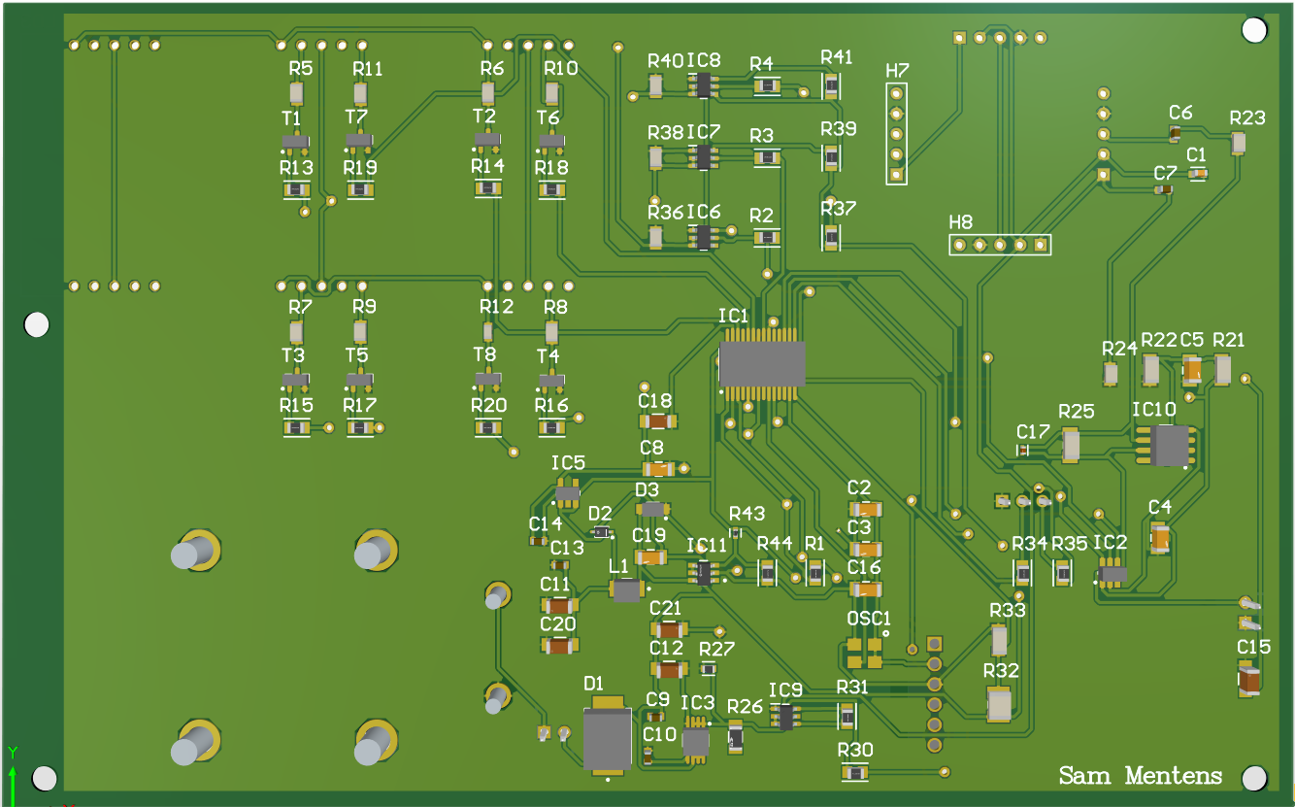

Figure 2 PCB top

All the SMDs are on one side of the PCB to ease soldering. If SMDs are put on both sides then the PCB needs to go two times in the oven. It can become a problem when u put the PCB in the oven for the second time, the SMDs on the bottom of the PCB could fall of if they are too heavy.

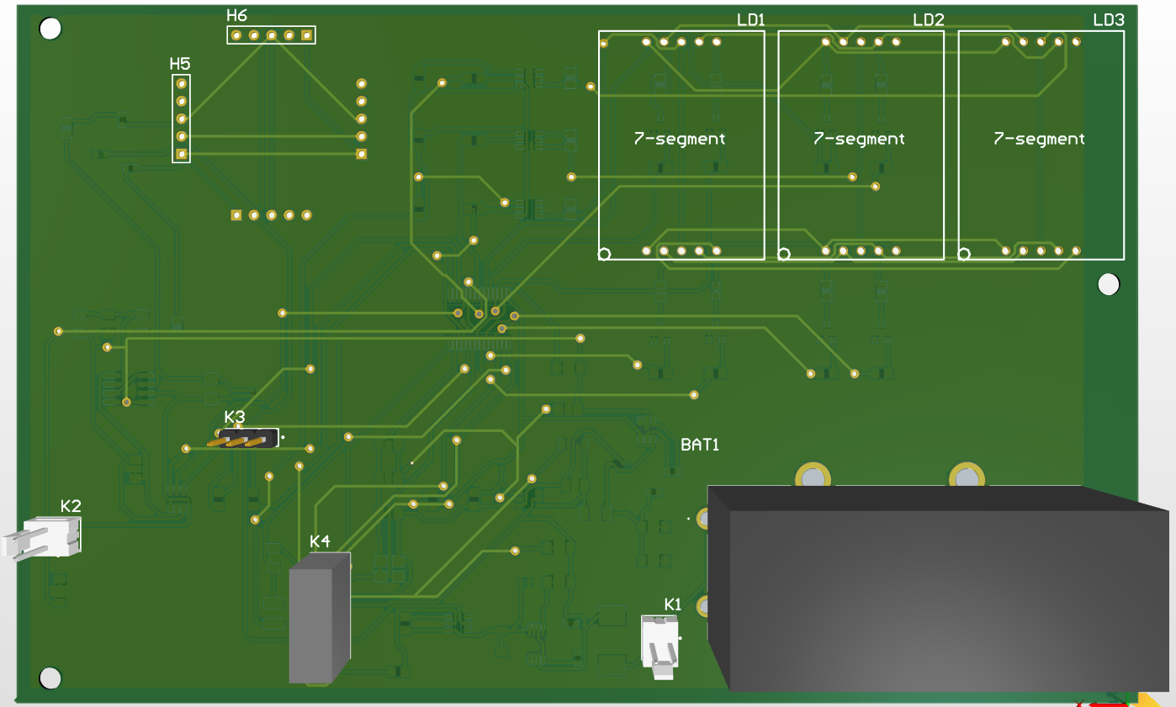

Figure 3 PCB bottom

On the bottom are nearly all the through hole components. The displays, battery and headers are on the same side of the PCB too only need place for them on one side in the case.

### Electrical

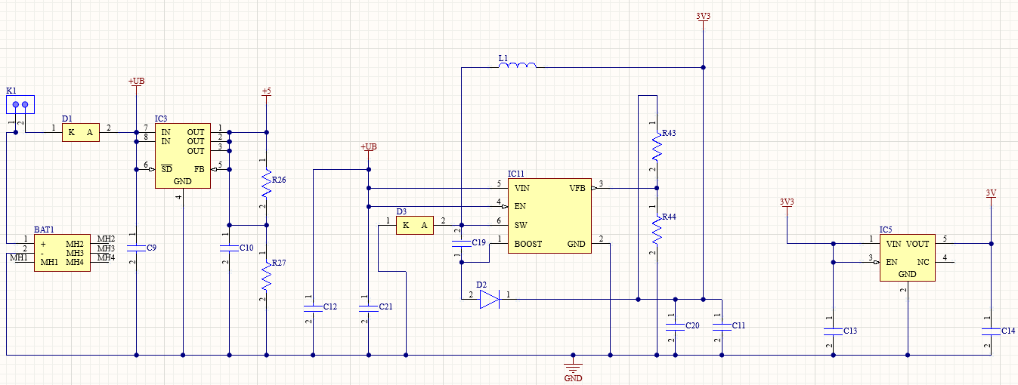

Figure 4 Schematic: power supply

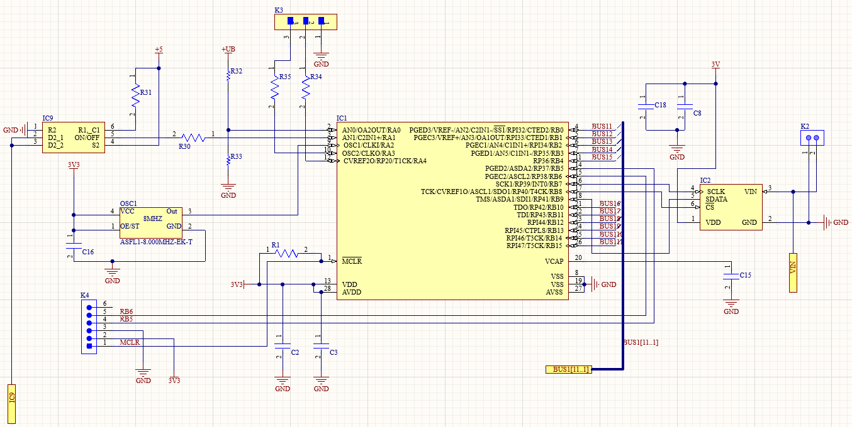

Figure 5 Schematic: dsPIC and clock

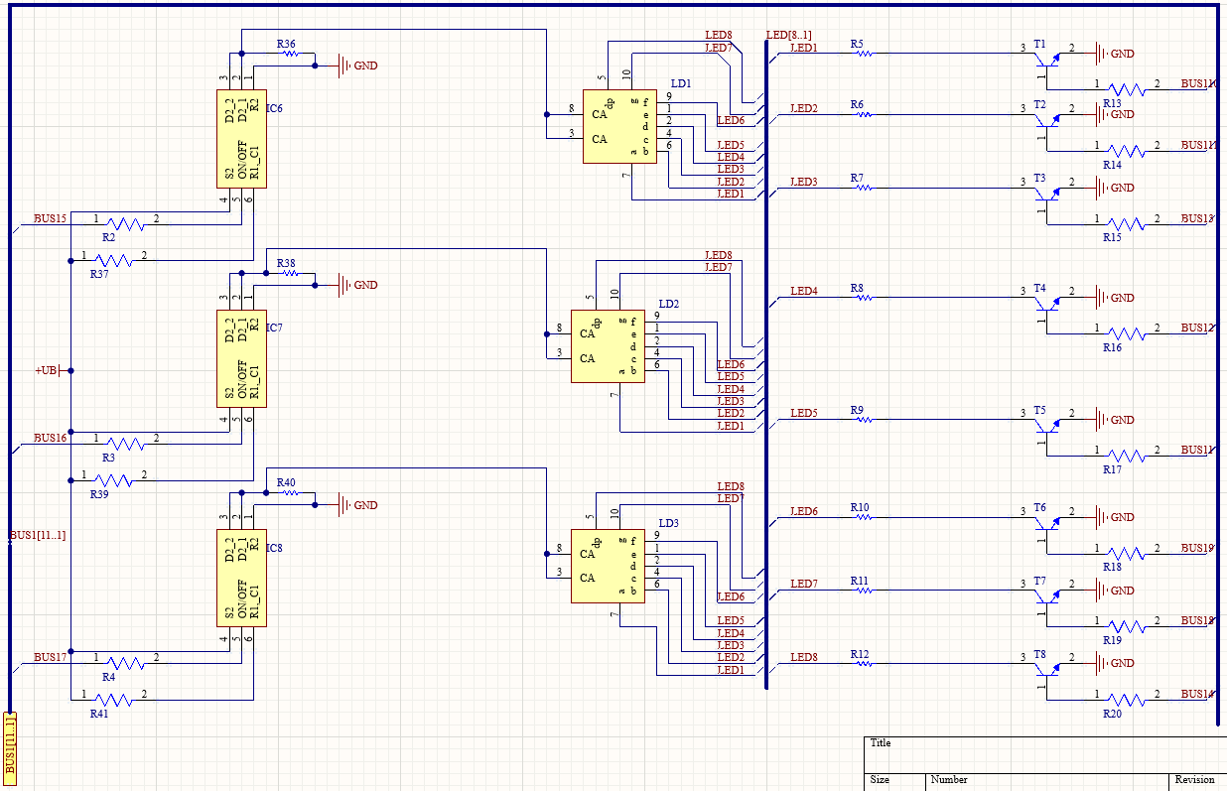

Figure 6 Schematic: 7-segment display

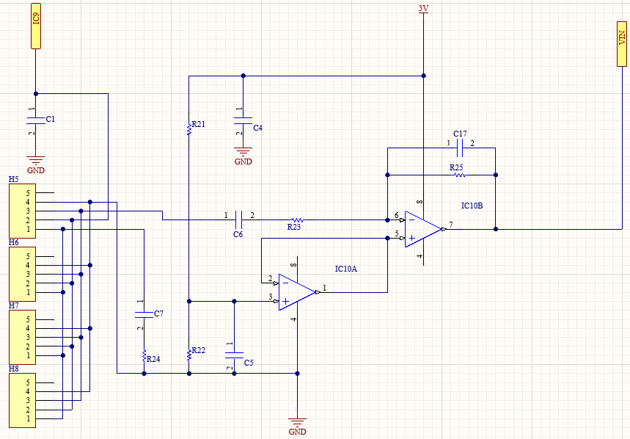

Figure 7 Schematic: Radar-Transceiver

The electric schematic is divided in four pieces so it is more clearly and not too close together. First there is the power supply. It generates four different voltages to supply different components throughout the circuit. “IC2 is an analog/digital converter which is controlled by IC1, this is a programmable microcontroller. The analog/digital convertion is based on a timer. The result is read with a spi-port. IC1 also controls the radar module. If nothing gets sampled then IC1 will turn the radar off using IC9. Lastly the 7-segment displays are also controlled by IC1.” [1]

### Mechanical

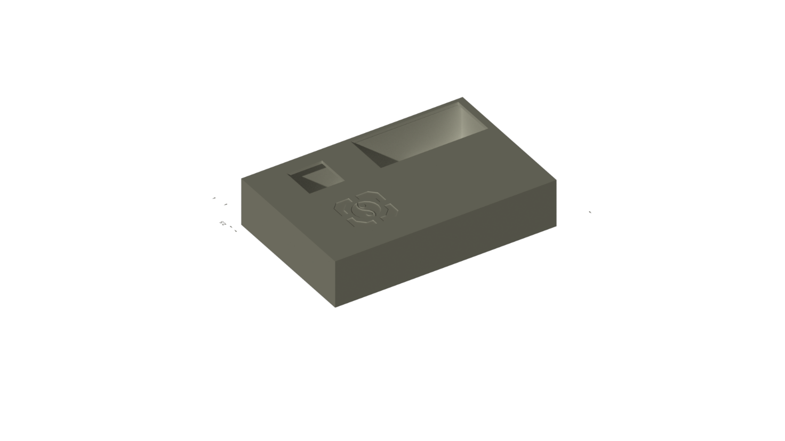

Figure 8 Case

This case is designed too be 3d-printed. It has seven holes in total 2 for the radar transceiver, on the top and on the bottom. This depends on where it is mounted on the PCB. Then also a hole for the 7-segment displays and four holes for the bolts too hold the case together.

# Discussion

I thought it would be a fairly easy project because I come from electro mechanics and I know a bit about electronics and programming but that was not the case here. The first problem I encountered was because of corona and scarcity in electric components. I had too order components from many different sites because they were not in stock everywhere and had long delivery times. Because of this I also ordered other variants of components that can take higher voltages or higher power. Then I had a small problem with soldering some of the ICs. Because the pins of ICs like IC1 are so close together they got short-circuited when put in the oven. IC1 had too be programmed but because I downloaded a pre-made program it did not work at first. The build files did not build right for an unknown reason. All the path names were wrong. The path names did all have too go too the location of the program but my program was not installed on the standard location for windows so I had too change it every time. Then another problem with the pre-made program was one of the libraries used in it. It was a difficult library to find if u know nothing about the program but this library is specific for programming this series of ICs.

# Reference list

|  |  |
| --- | --- |
| [1] | „Experimentele Doppler-radar,” *Elektor,* pp. 48-55, July & August 2018. |